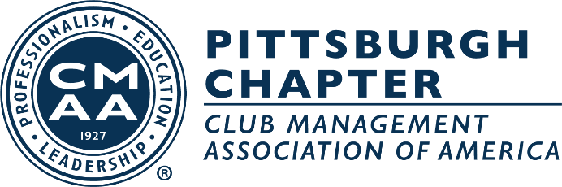

2023 Board of Director & Committee Assignments

President – Paul Korbar
Vice President – Adam Pletcher
Secretary/Treasurer – Kelly Caro

Board of Director:
Morgan Arnold
Chris Clodfelter
Mike Meissner
Ryan Prosowski
Tod Pierce
Ed Hollenberger
Hannah Street – Ex-Officio
Jeanne Davis – Managing Director

CHAPTER COMMITTEES
- Education – Mike Meissner & Chris Clodfelter
- Communications/Technology/Public Relations – Tod Pierce
- Membership – Ryan Prosowski & Ed Hollenberger
- Budget and Finance – Kelly Caro
- Bylaws – Adam Pletcher
- Vendor Show – Kelly Caro & Ed Hollenberger
- Yo-Pro – Morgan Arnold
- Nominating Committee – Hannah Street

CHAPTER-AFFILIATE ORGANIZATIONS
- Student Chapter – Morgan Arnold
- PGH Club Manager’s Foundation Representative – Adam Pletcher
- GLRC – Chris Clodfelter & Vince Daversa

CMAA NATIONAL INITIATIVES REPRESENTATIVES
- Certification – Ed Hollenberger
- Career Services – Ed Hollenberger
- Wine Society – Chris Clodfelter
- Conference – Chris Clodfelter & Other Board Conference Attendees
- CMAA Club Foundation – Adam Pletcher
- Legislative – Chris Clodfelter
- Research Chairman – Ryan Prosowski
- Corporate Relations Liaison – Kelly Caro

