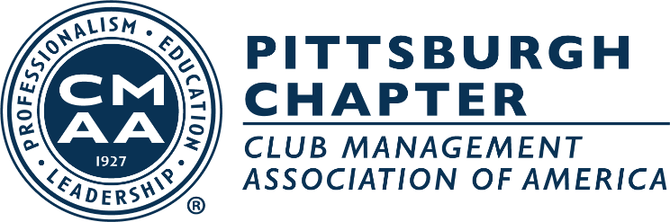

Pittsburgh Chapter CMAA
2022 Officers and Board of Directors

President
Paul Korbar, ‘24
Allegheny Country Club

Vice-President
Adam Pletcher, ‘22
Oakmont Country Club

Secretary-Treasurer
Kelly Caro, CCM, ‘24
Pittsburgh Field Club

Board of Directors
Chris Clodfelter, CCM, ‘22
Valley Brook Country Club

Jack Nelson, ‘22
Latrobe Country Club

Mike Meissner ‘24
Shannopin Country Club

Tod Pierce ‘25
Longue Vue Club

Ryan Prosowski ‘25
Westmoreland Country Club

Ed Hollenberger ‘25
Sewickley Heights Golf Club

Ex-Officio:
Hannah Street,
Wildwood Golf Club

