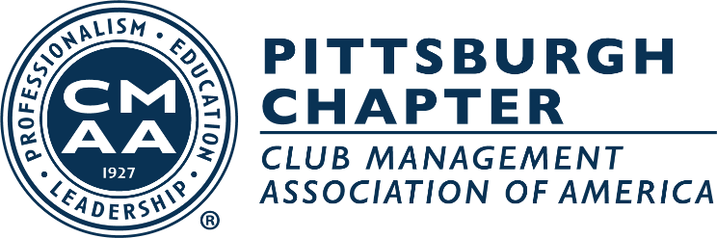

Pittsburgh Chapter CMAA
2023 Officers and Board of Directors

President
Paul Korbar, ‘24
Allegheny Country Club

Vice-President
Adam Pletcher, ‘26
Oakmont Country Club

Secretary-Treasurer
Kelly Caro, CCM, ‘24
Pittsburgh Field Club

Board of Directors

Mike Meissner ‘24
Shannopin Country Club

Tod Pierce ‘25
Longue Vue Club

Ryan Prosowski, CCM ‘25

Ed Hollenberger ‘25
Wildwood Golf Club

Chris Clodfelter, CCM, ‘26
Valley Brook Country Club

Morgan Arnold ‘26
Oakmont Country Club

Ex-Officio:
Hannah Street,
Wildwood Golf Club

